Screenshots or screencast URL: <URL of screenshots/screencast of the issue>

1. Navigate to www.topcoder.com

2. Select the option “My projects”.

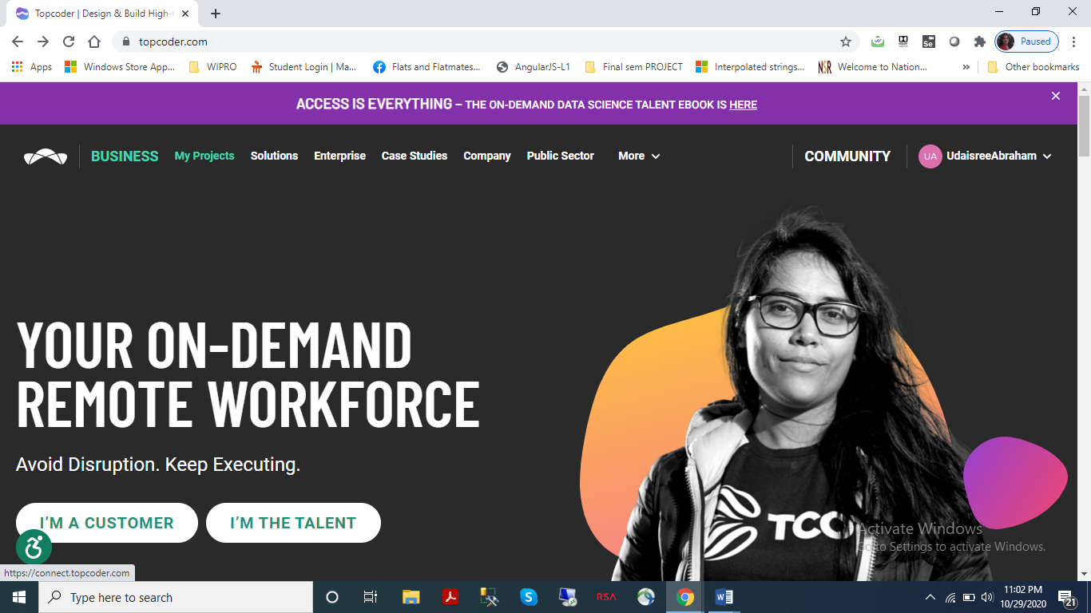

3. User is taken to https://connect.topcoder.com/. The tab “All Projects” is selected by default.

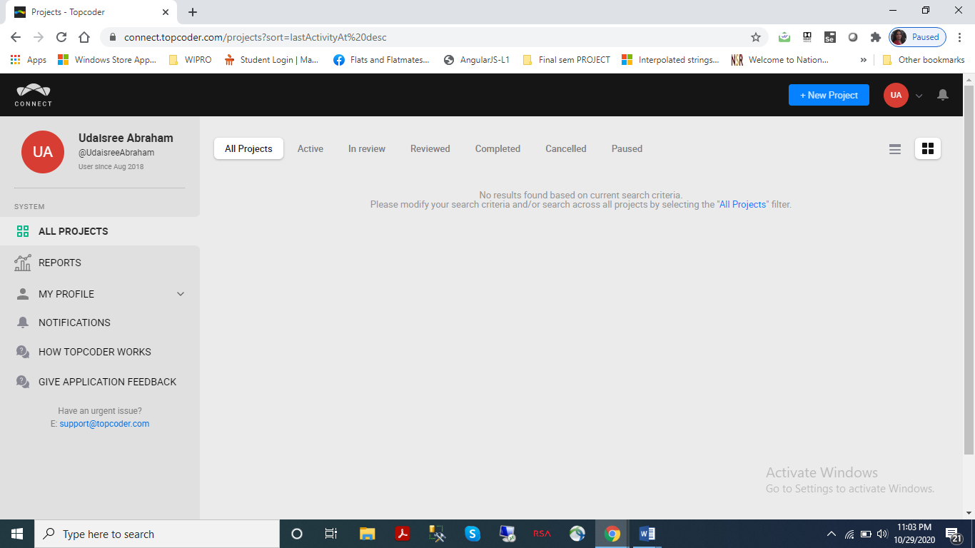

4. Navigate to “Active” tab on this page.

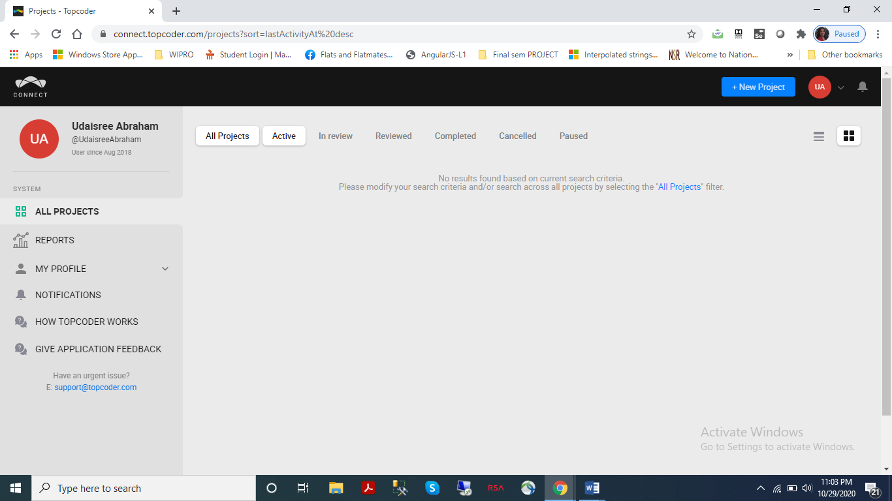

5. Select the back button on the Browser.

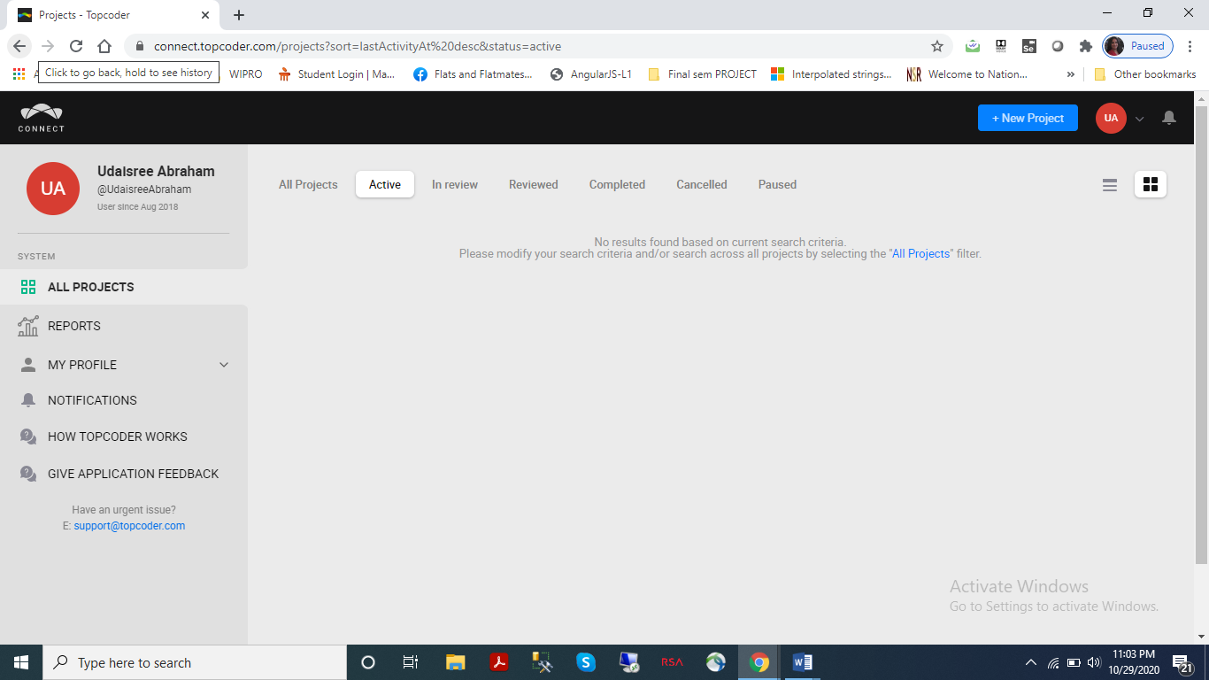

6. User stays on the same page, but tab “All Projects” is now selected.

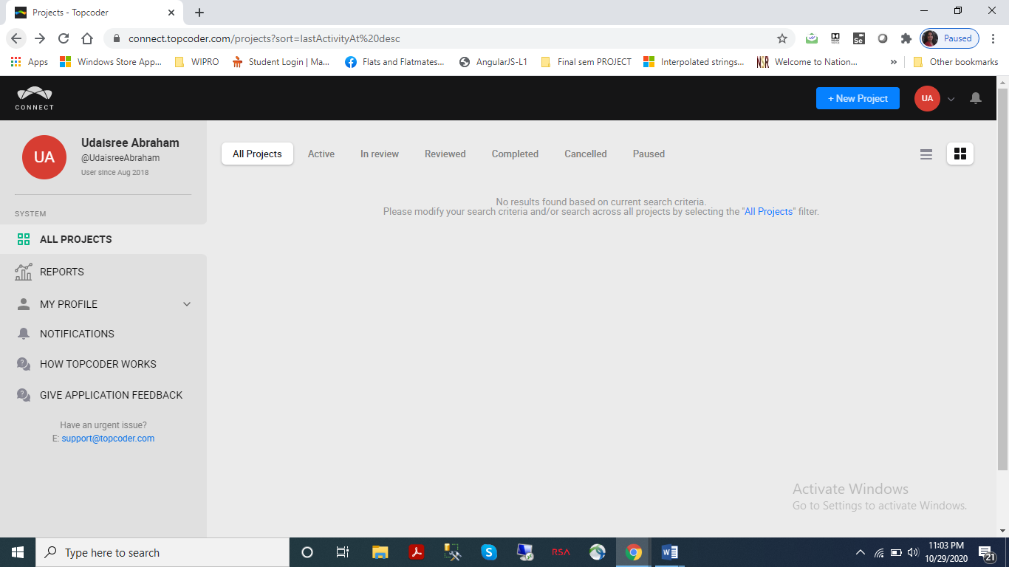

7. Select the back button on the Browser.

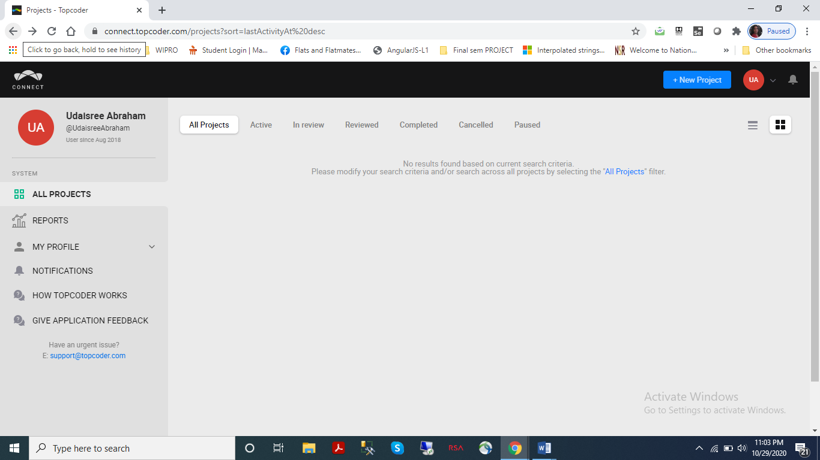

Actual Result: User stays on the same page. No change is seen.

Expected Result: User should be taken back to www.topcoder.com

